Weekly Lesson Plans
Teacher Name: Leecock
Subject/Grade: 6th SS
Unit of Instruction: Welcome Back!
Week of: September 15, 2020
Tuesday’s Lesson
Standard:

Unpack the Standard: What must students do to show mastery of this standard?

Objective  SWBAT+Strong Verb+Content+Product | Students will be able to: model the routines and procedures of the 6th grade team.
Language Can Do Descriptor
Body of Lesson
Activator (5 minutes) | While waiting for classmates to get on nearpod- What do you love learning about? Please be detailed and specific.
Lesson(15 minutes):  Explicit Model (I Do): Describe here how you will model the strategy while students observe and listen.  Checking for Understanding:  What questions will you ask students during the lesson?  How will you scaffold these questions? Keep the standard and the skill in focus! | Skill of Focus  Learn/describe the routines, procedures, and code of conduct of the 6th grade team  Explicit Model:  Students will participate in an interactive Nearpod describing the routines and procedures to help them be successful in 6th grade SS and on the 6th grade team. | Checking for Understanding Questions:  Discussion based on what students like most about learning.  - Asking students who they live with at home (nearpod “notecard”)- will be useful when determining potential distractions students could face at home
Small Group Activity:  (15 Minutes)  Student Model (We Do): Have one to two students come up and model the skill desired that was previously modeled by the teacher in the lesson  Checking for Understanding:  Ask students tiered questions throughout the model to check their peers work and to elaborate on students understanding.  Monitoring Aggressively:  During the independent practice, what type of monitoring are you using to collect live data and address students’ misconceptions? | Student Model:  Student volunteers will share what they learned in Elementary school SS classes.  Students will describe what they think they know in a nearpod collaborate post  Form of Monitoring Aggressively: | Checking for Understanding Questions:  Asking clarifying questions based upon students responses to what they know about SS prior to starting my course
 |  | Misconception Redirection:
Independent Practice:  (15 Minutes) | Independent/ Partner/Group Work (You Do):  Describe what they would like to learn about the Ancient world and students will describe how they like to learn/how they learn best.
Wrap-up (10 minutes)  What standard is being assessed? | Share 1 thing your classmates and I should know about you- you may include a picture to support
Homework Assigned
Wednesday’s Lesson
Standard:
Grade 6 Knowledge and Skills

Unpack the Standard: What must students do to show mastery of this standard?
Review standard, students will show what they know/remember about SS classes, will assess foundation to help move forward with upcoming units
Objective  SWBAT+Strong Verb+Content+Product | Students will be able to:  model the routines and procedures of the 6th grade team.  I can show and do my best on a mini geography skills game (preview of course)
Language Can Do Descriptor | Explain – Writing : Level 2 Explain by connecting short sentences, Level 4 Explain relationships between details or examples of supporting ideas
Body of Lesson
Activator (5 minutes) | What was the best part of being back to learning yesterday? Explain in detail.
Lesson(15 minutes):  Explicit Model (I Do): Describe here how you will model the strategy while students observe and listen.  Checking for Understanding:  What questions will you ask students during the lesson?  How will you scaffold these questions? Keep the standard and the skill in focus! | Skill of Focus  Learn/describe the routines, procedures, and code of conduct of the 6th grade team  Explicit Model:  - Review of class expectations  - Successes and challenges of online learning from the Spring | Checking for Understanding Questions:  Students will be asked to describe routines and why they are important to the online learning environment
Small Group Activity:  (15 Minutes)  Student Model (We Do): Have one to two students come up and model the skill desired that was previously modeled by the teacher in the lesson  Checking for Understanding:  Ask students tiered questions throughout the model to check their peers work and to elaborate on students understanding.  Monitoring Aggressively:  During the independent practice, what type of monitoring are you using to collect live data and address students’ misconceptions? | Student Model:  Students will participate in Nearpod collaborate boards describing what they like and dislike about online learning. Students will also share with me (privately- Nearpod open ended question) how they learn best and describe what makes it difficult for them to learn  Form of Monitoring Aggressively:  Pathways: Nearpod collaborate boards, discussing student responses, clarifying misconceptions thru discussion. Specific targeted feedback on collaborate responses. Nearpod open ended questions | Checking for Understanding Questions:
 |  | Misconception Redirection:
Independent Practice:  (15 Minutes) | Independent/ Partner/Group Work (You Do):  Preview of course game with 15 multiple choice style questions (Nearpod time to climb) and 1 bonus question from yesterday. Questions include identifying continents by shape, types of map by looking at them, and questions about some of the regions/people we will study this year  Following game will be debrief of how students did and reminding them its perfect if they didn’t get many correct (as this was preview game, they have not necessarily learned the material yet)
Wrap-up (10 minutes)  What standard is being assessed? | After the preview game played- what are you most excited to learn about this year? Be sure to explain.
Homework Assigned
Thursday’s Lesson
Standard:
Grade 6 Knowledge and Skills

Unpack the Standard: What must students do to show mastery of this standard?
Review standard, students will show what they know/remember about SS classes, will assess foundation to help move forward with upcoming units

Objective  SWBAT+Strong Verb+Content+Product | Apply map skills by identifying correct maps to use and comparing data on 2 different maps of the same location.
Language Can Do Descriptor | Explain – Writing : Level 2 Explain by connecting short sentences, Level 4 Explain relationships between details or examples of supporting ideas
Body of Lesson
Activator (5 minutes) | - What do teachers expect of you as a student?  - What do your parent(s)/Guardian(s) expect of you as a student?  - What do your classmates expect of you as a classmate?
Lesson(15 minutes):  Explicit Model (I Do): Describe here how you will model the strategy while students observe and listen.  Checking for Understanding:  What questions will you ask students during the lesson?  How will you scaffold these questions? Keep the standard and the skill in focus! | Skill of Focus  Types of Maps  Explicit Model:  Types of maps PPT- political vs. physical vs. theme | Checking for Understanding Questions:  What are the 5 important features of a map? What are basic parts most maps have? How do different parts of a map help so information?
Small Group Activity:  (15 Minutes)  Student Model (We Do): Have one to two students come up and model the skill desired that was previously modeled by the teacher in the lesson  Checking for Understanding:  Ask students tiered questions throughout the model to check their peers work and to elaborate on students understanding.  Monitoring Aggressively:  During the independent practice, what type of monitoring are you using to collect live data and address students’ misconceptions? | Student Model:  Students will be shown example maps and describe what type is shown and point out the details that prove them to be correct  Ex. 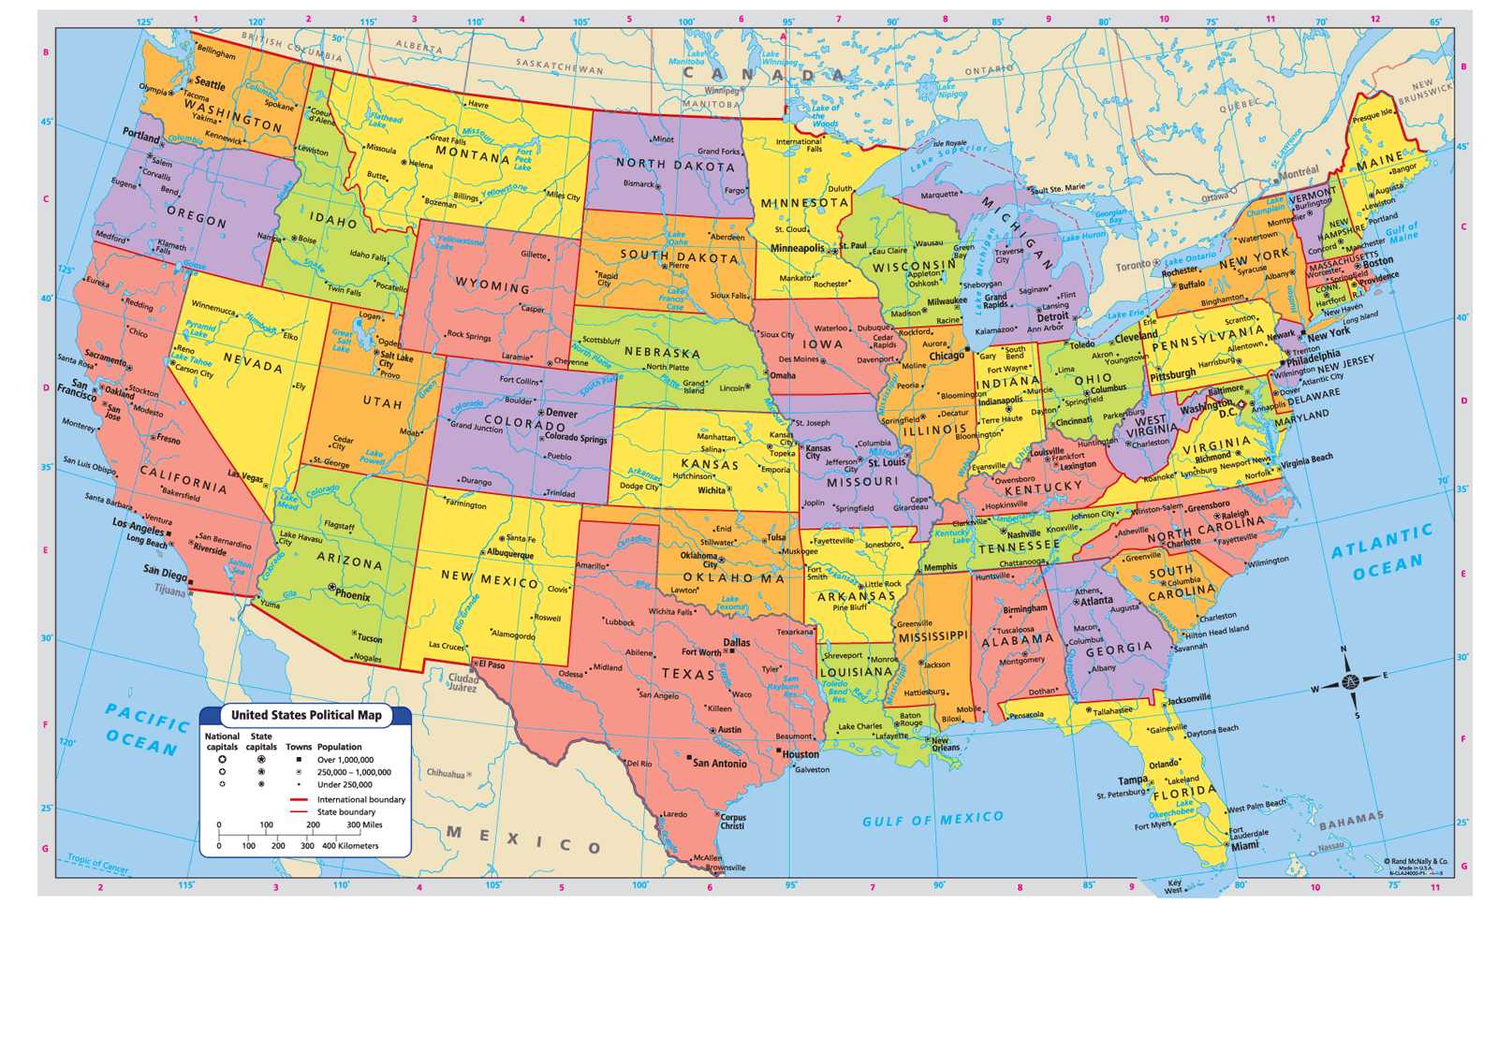 What type is this, how do you know you’re right/which parts of the map helped you?  Form of Monitoring Aggressively:  Pathways: Nearpod collaborate boards, discussing student responses, clarifying misconceptions thru discussion. Specific targeted feedback on collaborate responses. Nearpod open ended questions/utilize DRAW IT feature to have students mark up maps | Checking for Understanding Questions:  Students will be shown examples of political, physical, and thematic maps and asked to distinguish between them.
Misconception Redirection:
Explain how the Map’s key/legend hold the biggest clue to the type of map, focus on items/colors listed
Independent Practice:  (15 Minutes) | Independent/ Partner/Group Work (You Do):  1 - Students will continue with practicing which type of map is best to use and reading a maps legend/key (independent)  2 - Students will compare 2 maps of Brazil- Climate and Population, by answering a series of higher order thinking questions as they compare the data on the 2 maps (partner)
Wrap-up (10 minutes)  What standard is being assessed? | extra practice on types of maps- students will be given a list of map topics and will have to decide which map style would be best suited to find the information (political, physical, theme)
Homework Assigned | Mapping the Earth’s Surface article and questions
Friday’s Lesson
Standard:
Grade 6 Knowledge and Skills

Unpack the Standard: What must students do to show mastery of this standard?
Review standard, students will show what they know/remember about SS classes, will assess foundation to help move forward with upcoming units
Objective  SWBAT+Strong Verb+Content+Product | Students will be able to:  Apply knowledge by locating specific countries and cities on a map using latitude and longitude.  Analyze different types of maps to locate important information
Language Can Do Descriptor | Explain – Writing : Level 2 Explain by connecting short sentences, Level 4 Explain relationships between details or examples of supporting ideas
Body of Lesson
Activator (5 minutes)

Lesson(15 minutes):  Explicit Model (I Do): Describe here how you will model the strategy while students observe and listen.  Checking for Understanding:  What questions will you ask students during the lesson?  How will you scaffold these questions? Keep the standard and the skill in focus! | Skill of Focus  Using lat/long to determine absolute location  Explicit Model:  Determining latitude and longitude  Using line of latitude and longitude to create global grid to find absolute location. I will model finding cities in the US using coordinates | Checking for Understanding Questions:  Pre-recorded video lesson for students to watch and participate with later in day
Small Group Activity:  (15 Minutes)  Student Model (We Do): Have one to two students come up and model the skill desired that was previously modeled by the teacher in the lesson  Checking for Understanding:  Ask students tiered questions throughout the model to check their peers work and to elaborate on students understanding.  Monitoring Aggressively:  During the independent practice, what type of monitoring are you using to collect live data and address students’ misconceptions? | Student Model:  Nearpod lesson (adapted lesson created by Flocabulary)  Practice with new vocab from lesson and key terms from yesterday  Students will use newly acquired vocab to “Draw it” activity to draw in equator/prime meridian onto blank map. Will also use “draw it” to place coordinates on a map  Form of Monitoring Aggressively:  Pathways- using nearpod activities such as fill in the blank and matching pairs to help build vocabulary, draw it to practice labeling equator/prime meridian and using coordinate pairs to find absolute location on a map  Ex. | Checking for Understanding Questions:  Imagine you get lost on a hike while in Brazil. How would you be able to figure out your location? How do you think your answer would change if the same scenario happened 300 years ago?  Fill in the blank and matching activities- (nearpod)  Draw it activities (nearpod)
 |  | Misconception Redirection:
Independent Practice:  (15 Minutes) | Independent/ Partner/Group Work (You Do):  2 Jr. Scholastic “Map Skills Boot camp” worksheets  Students will have 2 skills practice worksheets from Jr Scholastic complete with readings, diagrams, and questions to interact with. Worksheet topics – globes & hemispheres and Latitude and Longitude
Wrap-up (10 minutes)  What standard is being assessed? | Do you think humans have become too reliant on GPS technology to find their way around? Do you think you would be able to navigate if GPS suddenly went offline? Be sure to explain using complete, detailed sentences.
Homework Assigned

